EXPERIMENT 2

ER DIAGRAM FOR SAILOR BOAT DATABASE

**Aim**: Draw an ER diagram of sailors’ database.

**Components:**

* Entities:
  + Sailor
  + Boats
* Relationship
  + reserves
* Attributes
  + Primary
    - Sid
    - Bid

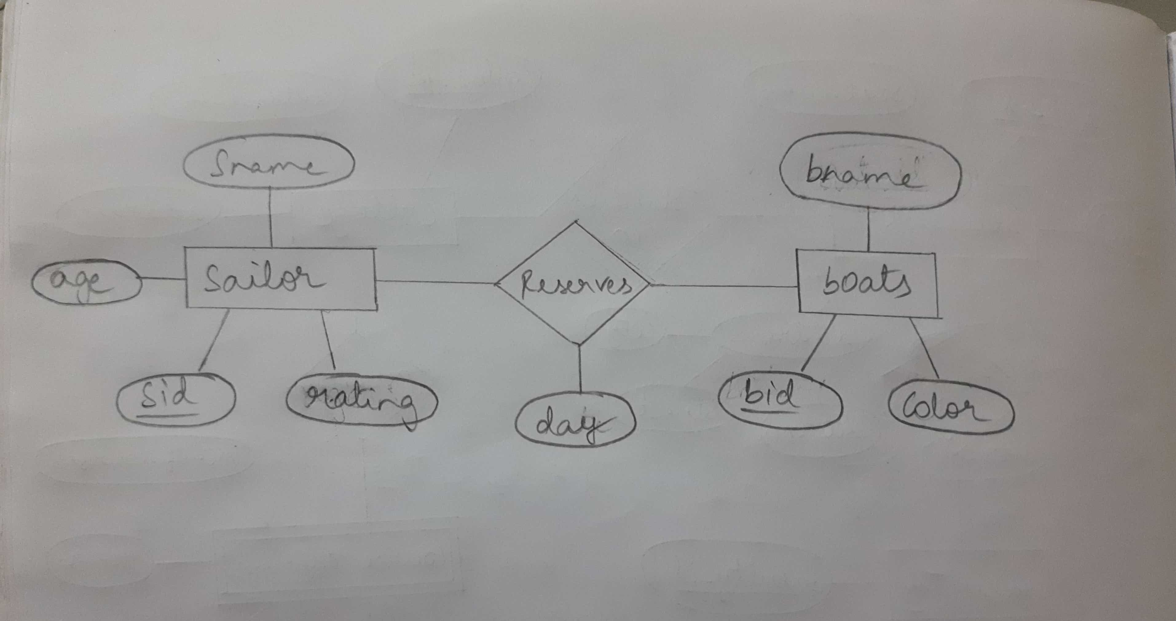

Rese-rves

Sailor

boats